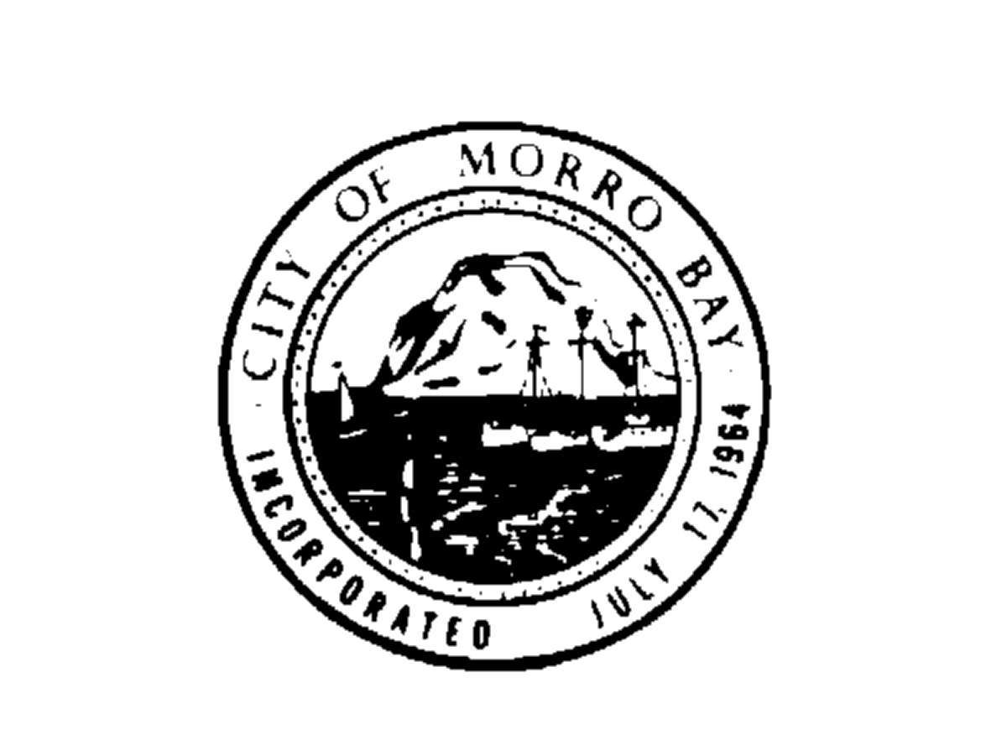
C I T Y O F M O R R O B A Y

P UBLIC WORKS ADVISORY BOARD

A G E N D A

The City of Morro Bay is dedicated to the preservation and enhancement of the quality of life. The City shall be committed to this purpose and will provide a level of municipal service and safety consistent with and responsive to the needs of the public.

Regular Meeting - Thursday, December 20, 2012
Veteran’s Memorial Building - 6:00 P.M.
209 Surf Street, Morro Bay, CA

Matt Makowetski, Chair
Ron Burkhart | Richard Rutherford
William Olson | Stephen Shively

NOTICE OF CANCELLED MEETING

THE REGULAR PUBLIC WORKS ADVISORY BOARD MEETING

SCHEDULED FOR

THURSDAY, DECEMBER 20, 2012

HAS BEEN CANCELLED

AND IS BEING RESCHEDULED TO

MONDAY, JANUARY 14, 2013

AT THE VETERAN’S MEMORIAL HALL

