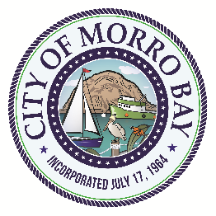

C I T Y O F M O R R O B A Y

PUBLIC WORKS ADVISORY BOARD

A G E N D A

The City of Morro Bay provides essential public services and infrastructure to maintain a safe, clean and healthy place for residents and visitors to live, work and play.

Regular Meeting - Wednesday, July 19, 2017
Veteran’s Memorial Building – 5:30 P.M.
209 Surf Street, Morro Bay, CA

Ric Deschler, Chair Steven Shively, Vice-Chair Christian Erlendson
John Erwin | Janith Goldman | Christopher Parker
 | Stewart Skiff

NOTICE OF CANCELED MEETING

THE REGULAR PUBLIC WORKS ADVISORY BOARD

MEETING SCHEDULED FOR

Wednesday July 19, 2017

HAS BEEN CANCELLED

The next regularly scheduled meeting will be held on
Wednesday, August 16, 2017 at 6:00 p.m.,
at the Veteran’s Memorial Building

