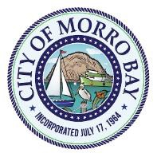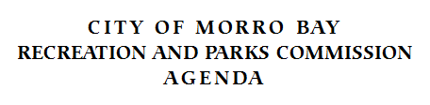

The City of Morro Bay provides essential public services and infrastructure to maintain a safe, clean and healthy place for residents and visitors to live, work and play.

Regular Meeting – Sept. 19, 2024
Veterans Memorial Building - 6 p.m.
209 Surf Street, Morro Bay, CA

Chairperson – Betty Winholtz Vice-Chairperson Drew Sidaris
Megan Fazio June Swall James Costanzo

NOTICE OF CANCELED MEETING

THE REGULAR RECREATION AND PARKS COMMISSION MEETING
FOR
THURSDAY, SEPTEMBER 19, 2024
HAS BEEN CANCELED

The next regularly scheduled meeting will be held
Thursday, November 21, 2024, at 6p.m.,
at the Veteran’s Memorial Building
209 Surf St., Morro Bay, CA 93442

